**Name**

**Advanced Programming in Java**

**Lab Exercise 12/7/2020**

1. Do you like treasure hunts? In this problem you are to write a program to explore the above array for a treasure. The values in the array are clues. Each cell contains an integer between 11 and 55; for each value the ten's digit represents the row number and the unit's digit represents the column number of the cell containing the next clue. Starting in the upper left corner (at 1,1), use the clues to guide your search of the array. (The first three clues are 11, 34, 42). The treasure is a cell whose value is the same as its coordinates. Your program must first read in the treasure map data into a 5 by 5 array. Your program should output the cells it visits during its search, and a message indicating where you found the treasure.

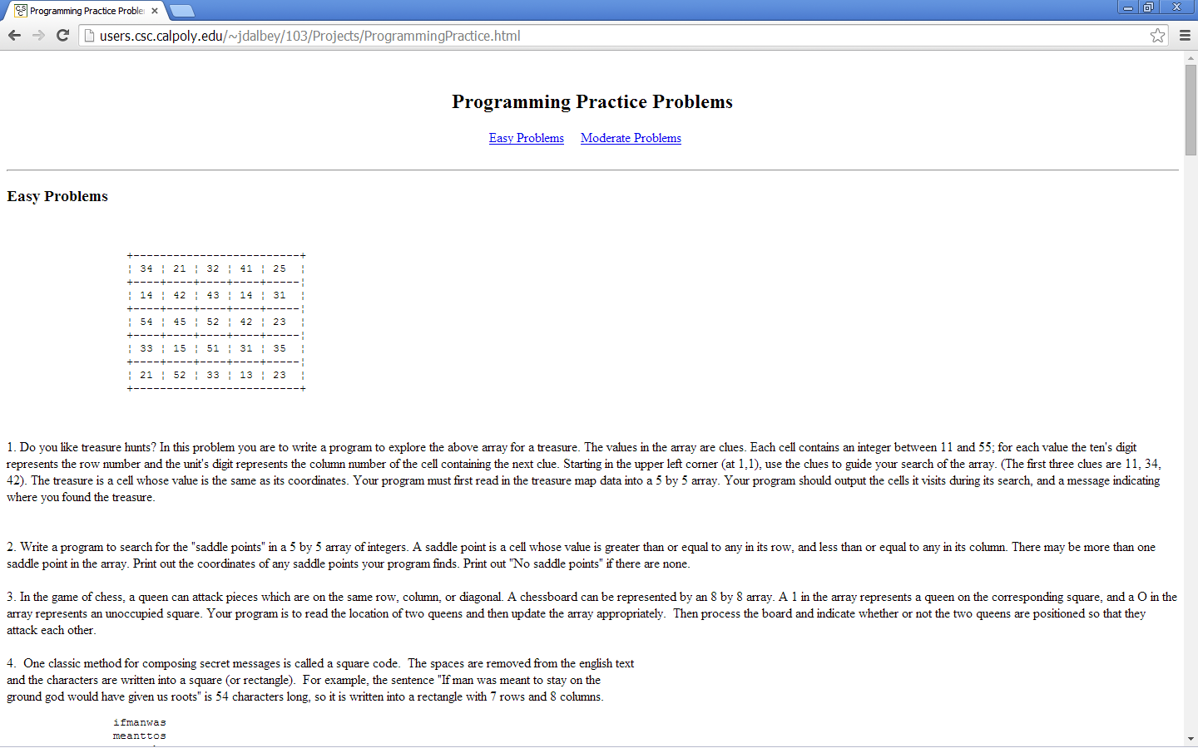

On the server, you will find a text file with these values that you can load in to your 2D array.

**Note: Java arrays are 0 based and locations in this array are not.**

Once your program has read in the array it should searching it for treasure reporting each location the treasure hunter is located and when it finds the treasure.

**When you program has found the treasure, submit your source code as well as the output from your program.**